YEAR 12 CHEMISTRY - ATCHE

TASK 8 PART A: PRACTICAL ASSESSMENT 2023

Identifying Unknown Organic Compounds
Part A: /12
Part B: /20
Total: /32

Suggested times:

- Part A (experimentation): 40 minutes
- Part B (validation): 30 minutes

Name: SOLUTIONS

Teacher: _________________________________________

Introduction:

The identification and characterization of the structures of unknown substances are an important part of organic chemistry.

In this experiment you will carry out several qualitative tests that will allow you to identify functional groups in unknown organic substances. You will apply what you have learned by characterizing the unknown organic compounds in terms of their chemical reactions.

You will be given SMALL liquid samples of

cyclohexene, ethanol, ethanoic acid and cyclohexane

each randomly labeled as A, B, C, and D. You will also be provided with common laboratory reagents including distilled water, bromine water (Br_{2 (aq)}), marble chips (CaCO₃), potassium permanganate (KMnO₄) solution and concentrated sulfuric acid.

Important notes:

- Use very small amounts of the lab reagents (e.g. 1 mL) in any chemical reaction to enable them to be the limiting reactant.
- Reagents available are: distilled water, bromine water (Br_{2 (aq)}), marble chips (CaCO₃), potassium permanganate solution (KMnO₄) and concentrated sulfuric acid.
- Plan to do the ‘simple’ tests to the maximum number of unknowns, leaving the more complex tests to fewer numbers of unknowns to save time.
- You cannot use acid-base indicators or ester formation as one of your tests.
- If you work out the last chemical by elimination, conduct a chemical test to ensure its identity is correct.

IN YOUR RESULTS FOLLOWING:

State all observations.

Write suitable chemical equations where possible to support your observations

Identify and state the chemical name of the unknowns.
RESULTS (12 marks)

There are 4 unknowns i.e. 3 marks for each unknown.

- 1 mark for clear concise observation stating all observable changes including colour, odour, layer separation etc.

- 1 mark for correct inference and making an attempt of writing chemical equation (where appropriate).

- 1 mark for correctly identifying the unknown.

IDENTITY OF UNKNOWNS:

A B C D

Task 8 Part B: Validation of Practical Results

- Write an appropriate aim for the experiment that you conducted. (1 mark)

Use chemical and physical tests to determine the identity of unknown organic substances (or anything else appropriate)

- Construct a flow chart or dichotomous key that would enable the identification of the four unknown substances supplied in part A. An example has been provided below. (2 marks)

BaSO₄, NaOH, Sugar, NH₄Cl
NaOH, Sugar, NH₄Cl
Sugar
NaOH
BaSO₄
NH₄Cl
Dissolve in water
Soluble
Insoluble
Litmus paper/universal indicator
Acidic
Neutral
Basic

2 marks for well-constructed (i.e. no sketch) & completed flow chart.

(1 mark for near-completed flow chart)

(0 mark for anything that does not look like a flow chart).

- With reference to your flow chart in question 2.
  - Briefly describe all tests that would be performed and how these would identify each substance. (4 marks)
4 marks for coherent, structured description of all procedures.

1 mark per test per substance

  - List two safety hazards that may arise during this experiment, for each hazard, provide a method to mitigate or minimize it. (4 marks)

1 mark for each hazard (e.g. sulfuric acid is corrosive and may burn skin)
1 mark for each mitigation strategy (e.g. wear gloves and glasses while handling sulfuric acid)

- Two of the unknown substances provided were soluble in water. Identify these species and use your understanding of intermolecular forces to explain why they are soluble. (4 marks)

- Ethanoic acid and ethanol (1 mark)
- Both of these substances exhibit Hydrogen bonding as their dominant intermolecular force (1 mark)
- The dominant intermolecular force in water is hydrogen bonding (1 mark)
- As the type and strength of intermolecular forces are similar, then the ethanol and ethanoic acid will dissolve in water (1 mark)

- Two of the unknown substances provided to you can produce a fruity smelling compound when reacted together.
  - Identify the two substances and write a balanced chemical equation for the reaction. Ensure that you include structural formulas in your response. (4 marks)

1 mark – ethanol and ethanoic acid
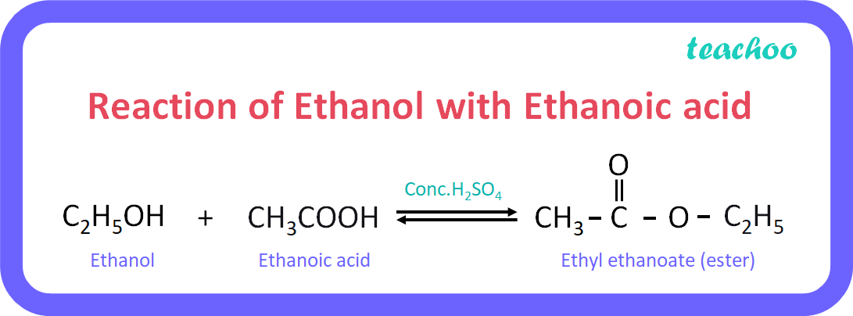

  - Using IUPAC nomenclature, name the main product that forms in this reaction. (1 mark)

Ethyl ethanoate

